**REST WEB SERVICE Report**

1. Visual Studio 2010 is downloaded. WCF aplication is selected by clicking on to New then project.

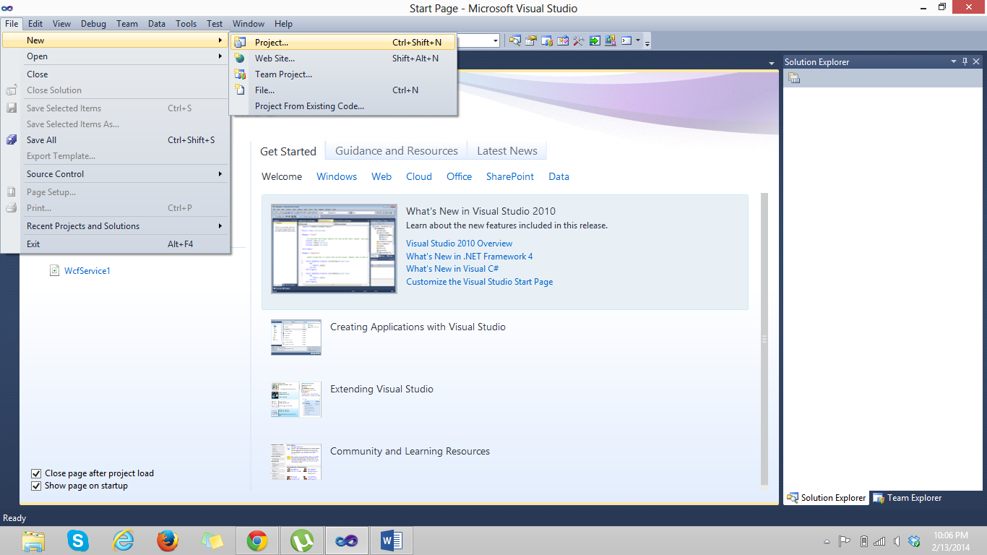

1. WCF Service application is selected.

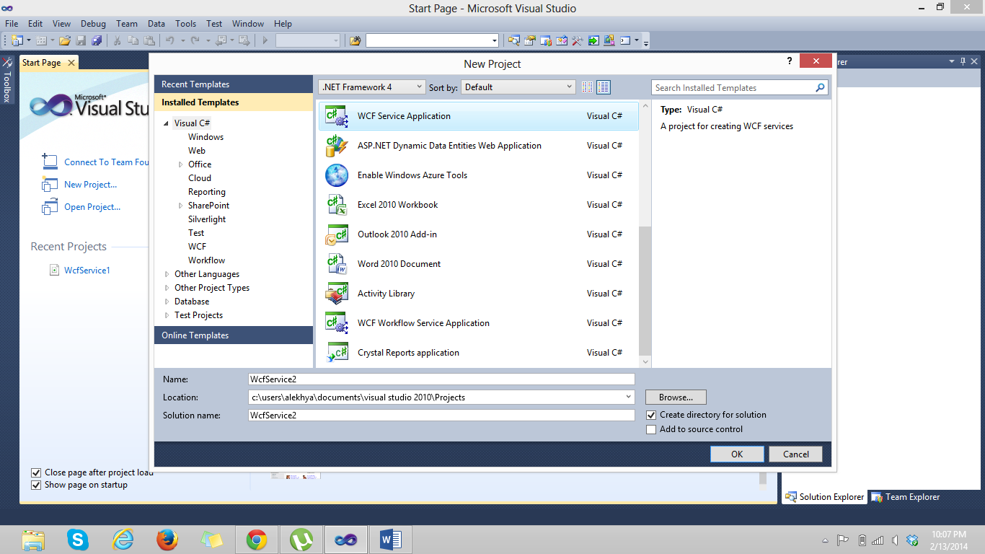

1. The code is:

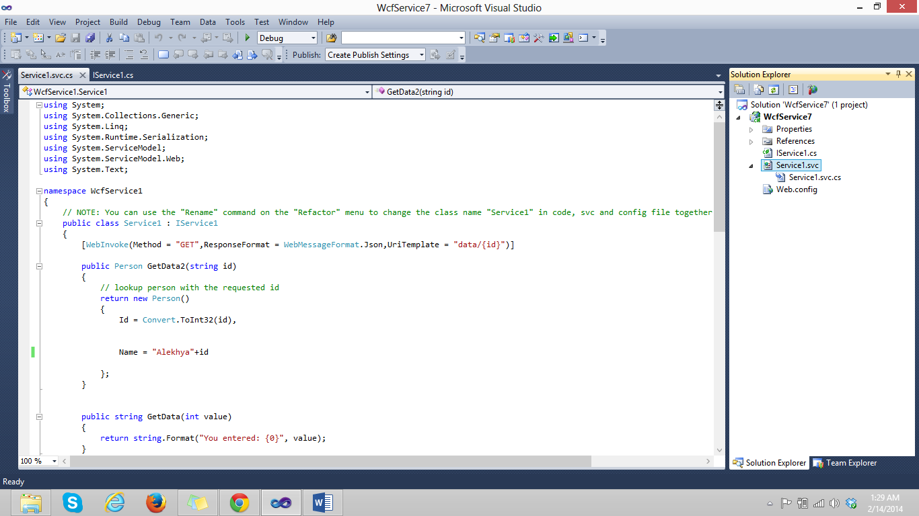

1. When viewed in desktop it appears with mentioned name and number.

